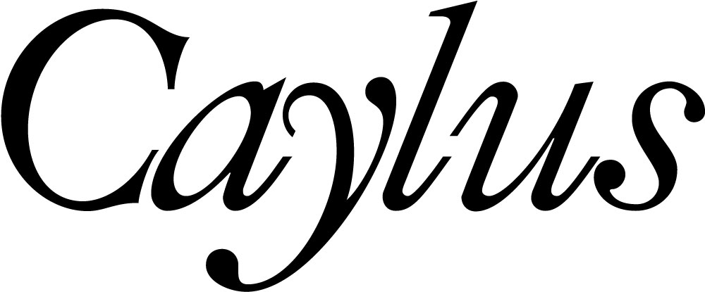

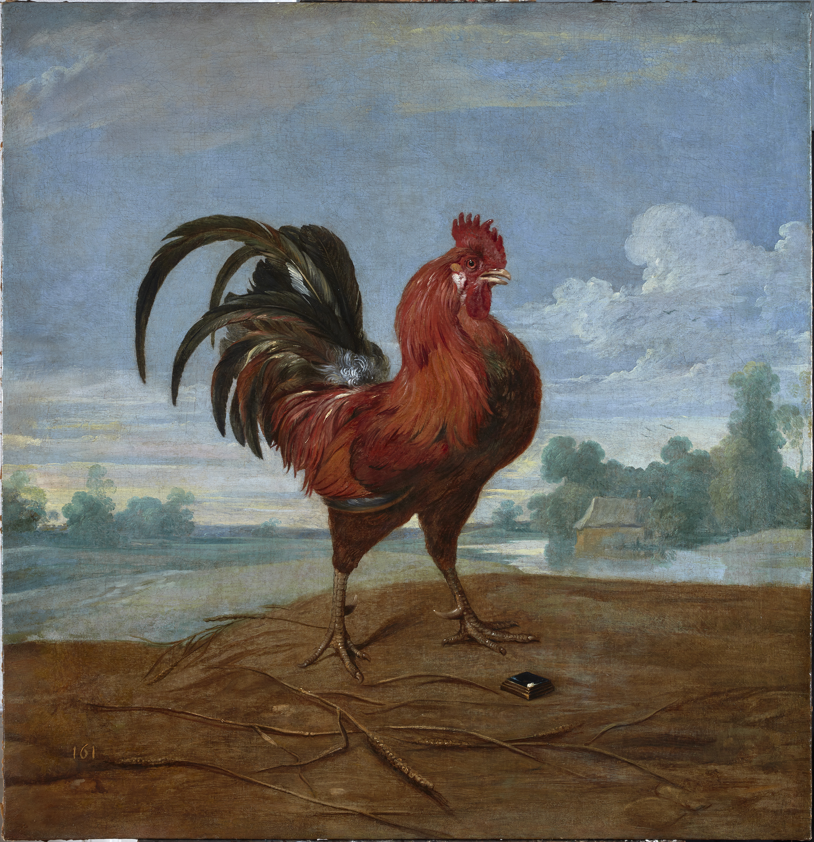

Frans Snyders
(Antwerp, 1579-1657)

The Fable of the Rooster and the Gem

Circa 1620-1630
Oil on canvas
98 x 98 cm
Provenance:
Marquis of Leganés 1637 (inv. 161); Marquis of Leganés 1642 (inv. 161); Marquis of Leganés 1655, Palace of San Bernardo (inv. 161; Count of Altamira 1726, Palace of San Bernardo, "sala entre los dos patios" (inv. 161); Vicente Pío Moscoso, Count of Altamira and Duke of Montemar, 1864 (inv. 455); Gonzalo Ulloa Ortega-Montañés (1833-1882), Count of Adanero; José María Ulloa Ortega-Montañés, Marquis of Castro-Serna, Count of Adanero (1839-1905); Matilde Ulloa y Calderón (1870-1932), Viscountess of Roda; Ramón Jordán de Urríes y Ulloa (-1960), Viscount of Roda; by descent to the present owners.

Related literature:
López Navío, J. L. “La gran colección de pinturas del Marqués de Leganés”, Analecta Calasanctiana, 8, 1962, p. 276.
Díaz Padrón, M. Pintura Flamenca en España. Phd. Universidad Complutense de Madrid, 1976, p. 1722.
Volk, M. C. “New light on a Seventeenth-Century Collector: The Marquis of Leganés”, Art Bulletin, 67, 1980, p. 264, num. 49.
Robels, H. Frans Snyders. Stillben und Tiermaler. Munich: Deutcher Kunstveriag, 1989, p. 310 and p. 517, núm. V42.
Koslow, S. Frans Snyders. Antwerp: Fonds Mercator Paribas, 1995, pp. 259-263, num. 8.
Pérez Preciado, J . J. El marqués de Leganés y las Artes. PhD. Madrid, Universidad Complutense de Madrid, 2010, p. 129 and ss.

A Flemish painter and draughtsman, Frans Snyders entered the studio of Pieter Brueghel the Younger in 1593, being also an apprentice to Hendrick van Balen. In 1602 he joined the Guild of Saint Luke as a master, and shortly afterwards he travelled to Rome and Milan, where he worked for Cardinal Federico Borromeo thanks to a recommendation from Jan Brueghel the Younger. On his return to Antwerp, in 1610, he married Margarita de Vos, sister of the painter Cornelis de Vos. Back in Italy he came into contact with Rubens, who would provide the figures for some of his paintings, at the same time as he would design pictures with a major development of the components of the still life so that Snyders could paint them. The result of this cooperation is Philopomenes recognised (Prado). The first paintings by Snyders are still very closely related to the small pictures referred to as breakfast still lifes, in the manner of Osias Beert and Clara Peeters, whereas the larger paintings recall the still-life tradition that Pieter Aertsen and Joachim Beuckelaer initiated towards the end of the 16th century in Flanders.

From 1620 onwards, his paintings grow in size, the display of items arranged on the table increases spectacularly and the compositional lines that depict the food on the board fan out in all directions, at the same time as he progressively discards pyramidal or diagonal lines. The outlines become more rounded and fluent and dynamically enliven the paintings; and the figures grow in emotional quality and expression. As of 1630 the most exuberant baroque style dominates his output. The colouring has evolved to lighter but more varied tones, and although he continues to collaborate with Rubens, who draws the figures for his compositions, his paintings are imbued with a greater decorative quality with a rich and varied layout.

In later years, especially in the 1640s, his work stagnates and his paintings undergo something of a regression, and he returns to the market scenes from years before. Only a hint of evolution is detected in the inclusion of landscape backgrounds, sometimes undertaken by Jan Wildens, whereby Snyders seeks to satisfy the tastes that are beginning to dominate art towards the middle of the century.

The other facet in which Snyders stands out is the painting of animals, which includes hunting scenes, fables and symbolic depictions, such as the concerts of birds. As in his still lifes, he upholds the same care for the naturalistic portrayal of the subjects, achieving astounding qualities in the anatomies and physical appearance of the figures, but in these hunting scenes what prevail are the more lively and dynamic compositions. On these paintings, too, he works alongside Rubens, who paints the figures for Snyders’ animals and vice versa. Their evolution mirrors that followed by the still lifes, with their sizes growing throughout his career, tending to become more horizontal, contributing to the liveliness of the scenes. At the same the baroque style of the compositions is enhanced by decorative and theatrical settings, whilst the technique becomes softer.

The interest Snyders’ work awoke amongst collectors and princes throughout Europe had a postscript of remarkable quality in Spain, with his involvement in the ornament for the Torre de la Parada, for which he painted several hunting scenes and fables. Furthermore, the gifts made by renowned collectors of Flemish painting, such as the Marquis of Leganés, completed the collection of Snyders held by Philip IV and kept at the Alcázar in Madrid, which explains his considerable presence in the Prado.

Our painting was part of the collection of Don Diego Mesía y Guzmán, Marquis of Leganés. He owned a series of six based on different Aesop’s fables documented in his testamentary as follows: The Lion and the Mouse, The Hare and the Turtle, The Dog and the Bridge, The Goat and the Wolverines, The Heron and the Swan and The Rooster and a Diamond. Another version by the artist is in the collection of the Suermondt-Ludwig-Museum, painted c. 1620-1630.
[Fig. 1].
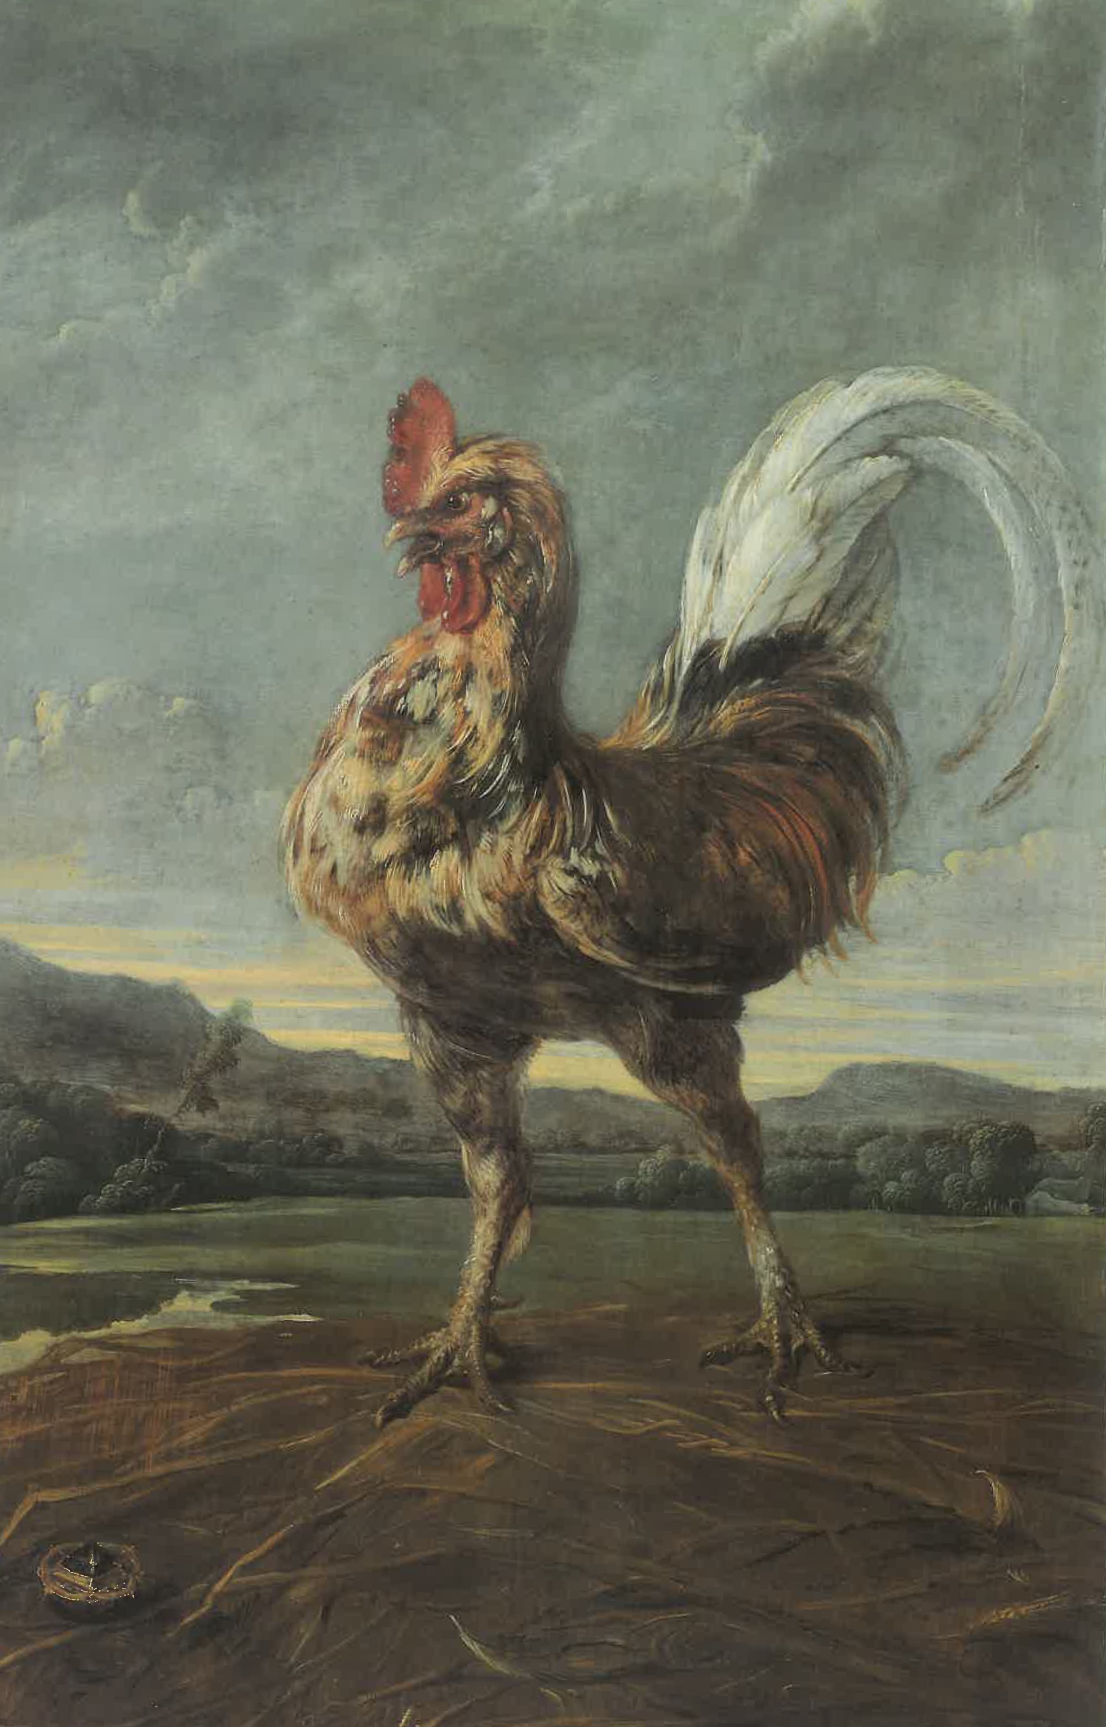
Fig. 1. Frans Snyders. The Fable of the Rooster and the Gem, ca. 1620-1630. Oil on panel,
100 x 67 cm. Aachen, StÄdstisches Suermondt-Ludwig-Museum (R 202).

